Introduction
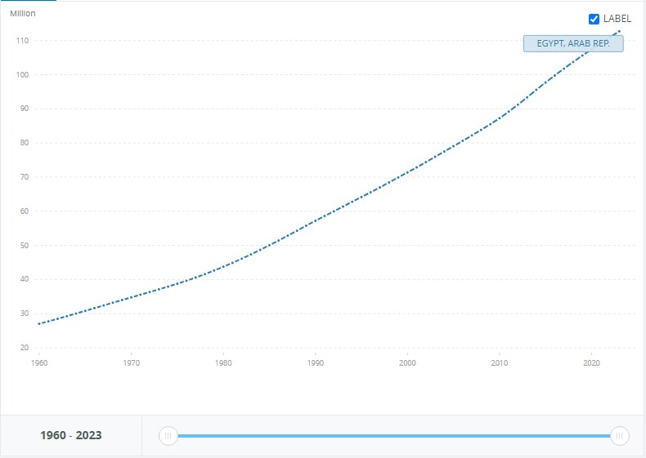
Population growth is a threatening problem that faces Egypt which has a population of 106,890,565. As illustrated in Figure (1), the population in Egypt went from 27M to 112M in 63 years with a 314% increase in population and 2% growth a year, the Greater Cairo Metropolitan Area (GCMA) which has fifth of Egypt’s population is expected to further increase to 24 million by 2027, with Birth numbers exceeding deaths which makes Egypt more and more crowded than ever in each minute passing, as a direct result, more people are using up the same resources, space, and public sectors. So, population growth in this area can cause urban congestion.
Fig. 1 Rate of Egypt's population growth
After research a multitude of solutions already tried were found, two of which are Tower Bridge and Hawthorne bridge. Tower Bridge is a bascule bridge operated with a hydraulic system. One of the strength points of this bridge is its efficiency as it is significant in London transportation because it carries 40,000 people and 21,000 vehicles. It opens 800-1,000 times per year to allow for the marine traffic to pass. However, the bridge can’t bear earthquakes. As it has Sensitivity to vibrations. When the bridge bascules open, they're subject to vibrations and oscillations. Over time, this can cause wear and tears. The second prior solution is Hawthorne bridge. Hawthorne Bridge is a vertical lift bridge. From the points of strengths of the bridge Transportation Importance: Hawthorne Bridge continues to serve as an important transportation route between downtown Portland and the South Waterfront neighborhood. Yet, the bridge remained intact after said modifications. From the points of weakness of the bridge is Earthquake Vulnerability According to Washington County, Portland metropolitan area has experienced six earthquakes of 5.0 magnitude or greater, which flags Portland as earthquake-prone region. Since Hawthorne Bridge is an old structure, it may be more susceptible to damage in the event of a major earthquake.
The solution that has been chosen is a bridge. The truss type used in it is Warren truss with verticals as it is efficient for short spans, and it distributes the force equally on the members because it consists of equilateral triangles. The opening mechanism of the bridge is a hydraulic bascule. The machinery ensures that the bridge travels upwards and the counterweights downwards. This ensures that everything is balanced during the vertical movement. Hydraulic bridges provide smooth and accurate acceleration and deceleration.

.

